PMG201c.PE1_University Library Digitalization Project
Given the context for the project as following, you are the PM for this project
A university is undertaking a digitalization project to convert its entire library collection
into a digital format. The system must allow students and faculty to search, view, and download books, research papers, and journals. The project includes:
- Scanning 50,000 books and 100,000 research papers.
- Creating an search engine to retrieve content efficiently.
- Implementing user authentication for controlled access.
- Ensuring data security and backup.
The project duration is 12 months, with a budget of $500,000. The university has hired an IT company to develop the software, and the library staff will be responsible for categorizing and verifying scanned content.
Request 1 (weight 15%)
Define at least 2 project objectives using SMART criteria (objectives that are Specific, Measurable, Achievable, Relevant, and Time-bound, ensuring clarity, trackability, and focus for achieving desired outcomes).
Request 2 (weight 25%)
Define the scope for this project which include in-scope items, exclusive (or out-of-scope) items, and the deliverables that you would need to provide for the project.
Request 3 (weight 25%)
Assume that you have defined and estimate schedule for one of main project deliverables with below high-level activities as following:
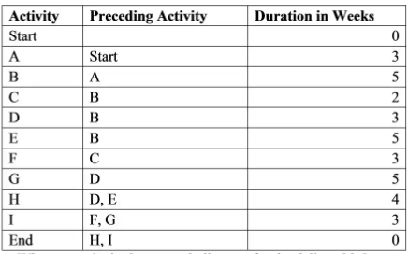
a. What are paths in the network diagram for the deliverable?
b. Identify the minimum duration to complete that deliverable?
c. What are activities which have the most flexibity (in term of time)?
Request 4 (weight 35%)
The university is digitalizing 50,000 books and 100,000 research papers. After 5 months, the project is behind schedule, having only scanned 15,000 books (30%) instead of the planned 25,000 (50%). The AI search feature is incomplete, causing retrieval issues.
a. Evaluate project performance after 5 months based on schedule and cost
b. Suggest corrective actions to ensure project completion within the next 7 months.

